# Pizza Sales SQL Queries

## KPIs

### Total revenue

select SUM(total_price) as total_revenue from pizza_sales;

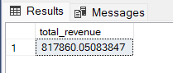

### Average Order Value

select sum(total_price)/count(distinct(order_id)) as avg_order_value from pizza_sales;

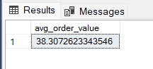

### Total Pizzas Sold

select sum(quantity) as total_pizza_sold from pizza_sales;

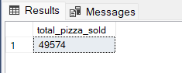

### Total Orders

select count(distinct(order_id)) as total_orders from pizza_sales;

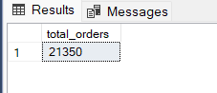

### Average Pizzas per Order

select cast(cast(sum(quantity) as decimal(10,2))/

cast(count(distinct(order_id)) as decimal(10,2)) as decimal(10,2))

as avg_pizza_per_order from pizza_sales;

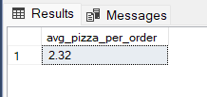

## Charts Requirements

### Daily trend for Total Orders

Select DATENAME(dw,order_date) as day,count(distinct(order_id)) as total_orders

from pizza_sales

group by DATENAME(dw,order_date)

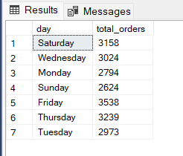

### Monthly trend for Total Orders

Select DATENAME(month,order_date) as day,count(distinct(order_id)) as total_orders

from pizza_sales

group by DATENAME(month,order_date)

order by total_orders desc

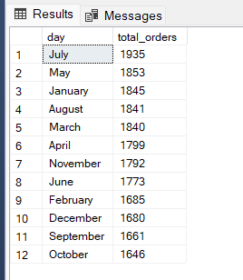

### % of sales by Category

select pizza_category, sum(total_price)*100 / (select sum(total_price) from pizza_sales) as pct_of_total_sales from pizza_sales

group by pizza_category

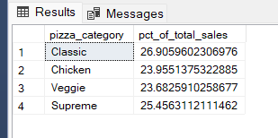

### % of sales by Size

select pizza_size, sum(total_price)*100 / (select sum(total_price) from pizza_sales) as pct_of_total_sales from pizza_sales

group by pizza_size

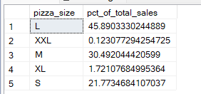

### Total Pizzas Sold by Pizza Category

select pizza_category, sum(quantity) total_pizzas from pizza_sales

group by pizza_category

order by total_pizzas

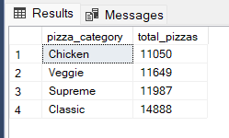

### Top 5 bestsellers by Revenue

select top 5 pizza_name, sum(total_price) as revenue from pizza_sales

group by pizza_name

order by revenue desc

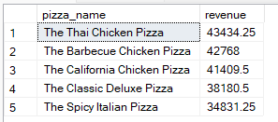

### Top 5 bestsellers by Total Quantity

select top 5 pizza_name, sum(quantity) as total_pizzas_sold from pizza_sales

group by pizza_name

order by total_pizzas_sold desc

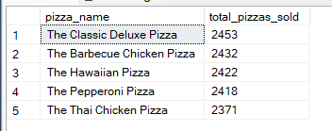

### Top 5 bestsellers by Total Orders

select top 5 pizza_name, count(distinct(order_id)) as total_orders from pizza_sales

group by pizza_name

order by total_orders desc

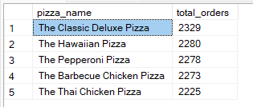

### Bottom 5 bestsellers by Revenue

select top 5 pizza_name, sum(total_price) as revenue from pizza_sales

group by pizza_name

order by revenue asc

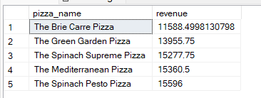

### Bottom 5 bestsellers by Total Quantity

select top 5 pizza_name, sum(quantity) as total_pizzas_sold from pizza_sales

group by pizza_name

order by total_pizzas_sold asc

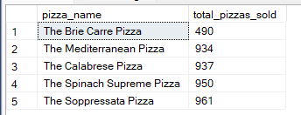

### Bottom 5 bestsellers by Total Orders

select top 5 pizza_name, count(distinct(order_id)) as total_orders from pizza_sales

group by pizza_name

order by total_orders asc

